**916217-G Pavan Kumar**

**Stage 3 - MVC components in Web page rendering, Data binding concepts in .Net core - Day 63 – Handson 1**

**Create a Razor view to list a few Organizations at Hyderabad and highlight the one that has recently build its largest offshore office at India.**

**Controller**

using Microsoft.AspNetCore.Mvc;

using Microsoft.Extensions.Logging;

using System;

using System.Collections.Generic;

using System.Diagnostics;

using System.Linq;

using System.Threading.Tasks;

using WebApplication1.Models;

namespace WebApplication1.Controllers

{

public class HomeController : Controller

{

private readonly ILogger<HomeController> _logger;

public HomeController(ILogger<HomeController> logger)

{

_logger = logger;

}

public IActionResult Index()

{

return View();

}

public IActionResult Privacy()

{

return View();

}

public IActionResult ITOrganizations()

{

List<string> Itlist = new List<string>();

Itlist.Add("Microsoft www.microsoft.com");

Itlist.Add("CTS www.cognizant.com");

Itlist.Add("Google");

Itlist.Add("Amazon");

Itlist.Add("TCS");

return View(Itlist);

}

[ResponseCache(Duration = 0, Location = ResponseCacheLocation.None, NoStore = true)]

public IActionResult Error()

{

return View(new ErrorViewModel { RequestId = Activity.Current?.Id ?? HttpContext.TraceIdentifier });

}

}

}

**ITOrganization.cshtml**

@{

ViewData["Title"] = "ITOrganizations";

}

<h1>ITOrganizations</h1>

@model List<string>

@foreach (var name in Model)

{

<div>

@if (name.Equals("Amazon"))

{

<span style="color:red"><b>@Html.DisplayFor(i => name, new { @class = "clr" })</b></span>

}

else

{

<span>@Html.DisplayFor(i => name)</span>

}

</div>

}

**OutPut**

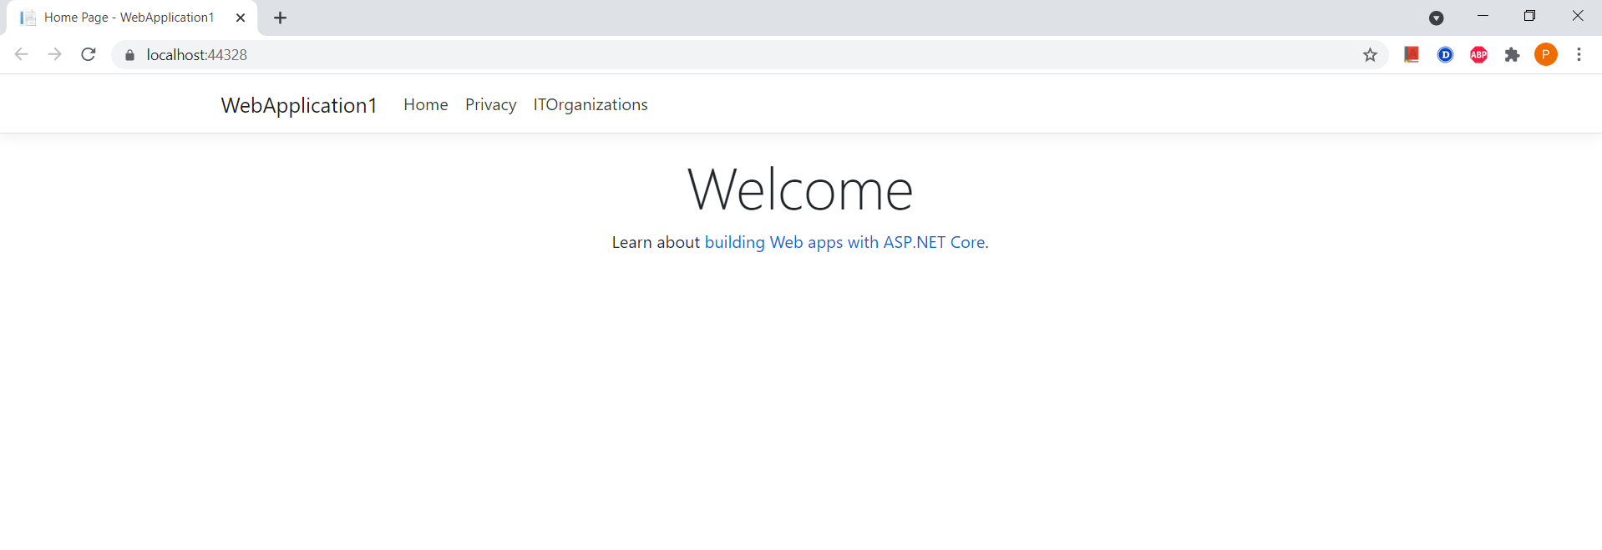

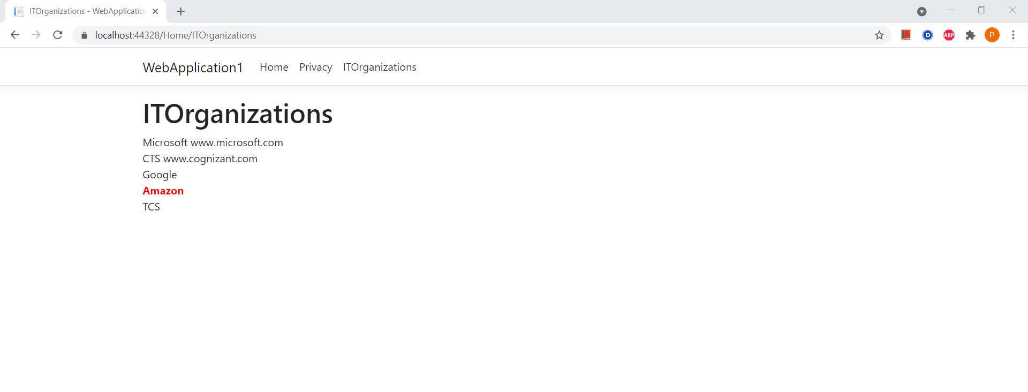

**Create a Razor view to list few employee details using Model data binding**

**Controller.cs**

using Microsoft.AspNetCore.Mvc;

using Microsoft.Extensions.Logging;

using System;

using System.Collections.Generic;

using System.Diagnostics;

using System.Linq;

using System.Threading.Tasks;

using WebApplication1.Models;

namespace WebApplication1.Controllers

{

public class HomeController : Controller

{

private readonly ILogger<HomeController> _logger;

public HomeController(ILogger<HomeController> logger)

{

_logger = logger;

}

public IActionResult Index()

{

return View();

}

public IActionResult Privacy()

{

return View();

}

public IActionResult ITOrganizations()

{

List<string> Itlist = new List<string>();

Itlist.Add("Microsoft www.microsoft.com");

Itlist.Add("CTS www.cognizant.com");

Itlist.Add("Google");

Itlist.Add("Amazon");

Itlist.Add("TCS");

return View(Itlist);

}

public IActionResult GetEmployeeList()

{

List<Employee> emplst = new List<Employee>();

emplst.Add(new Employee()

{

Id = 1,

Name = "John",

Salary = 10000,

IsPermanent = true

});

emplst.Add(new Employee()

{

Id = 2,

Name = "Smith",

Salary = 5000,

IsPermanent = false

});

emplst.Add(new Employee()

{

Id = 3,

Name = "Mark",

Salary = 5000,

IsPermanent = false

});

emplst.Add(new Employee()

{

Id = 4,

Name = "Mary",

Salary = 5000,

IsPermanent = false

});

return View(emplst);

}

[ResponseCache(Duration = 0, Location = ResponseCacheLocation.None, NoStore = true)]

public IActionResult Error()

{

return View(new ErrorViewModel { RequestId = Activity.Current?.Id ?? HttpContext.TraceIdentifier });

}

}

}

**GetEmployeeList.cshtml**

@{

ViewData["Title"] = "GetEmployeeList";

}

<h1>GetEmployeeList</h1>

@model List<WebApplication1.Models.Employee>

@{

<div class="row">

<span class="col-md-4">Name</span>

<span class="col-md-4">Salary</span>

<span class="col-md-4">IsPermanent</span>

</div>

}

@foreach (var emp in Model)

{

<div class="row">

@if (emp.IsPermanent.Equals(true))

{

<span class="col-md-4" style="color:red"><b>@emp.Name</b></span>

<span class="col-md-4" style="color:red"><b>@emp.Salary</b></span>

<span class="col-md-4" style="color:red"><b>@emp.IsPermanent</b></span>

}

else

{

<span class="col-md-4">@emp.Name</span>

<span class="col-md-4">@emp.Salary</span>

<span class="col-md-4">@emp.IsPermanent</span>

}

</div>

}

**Output**

